Cloud Development A

CLVD6211

Part 2

ST10379182

Entity Relationship Diagram:  
  
  
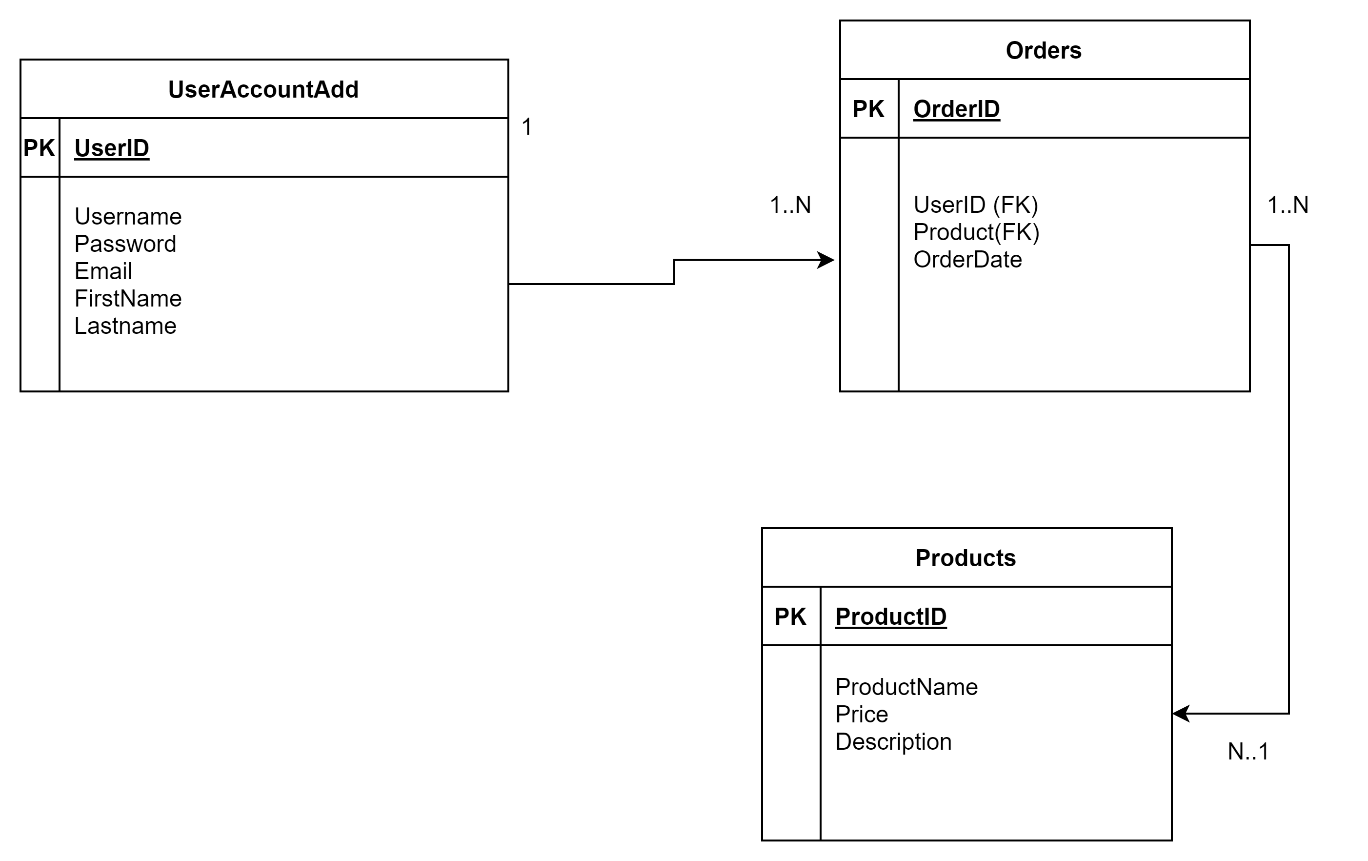

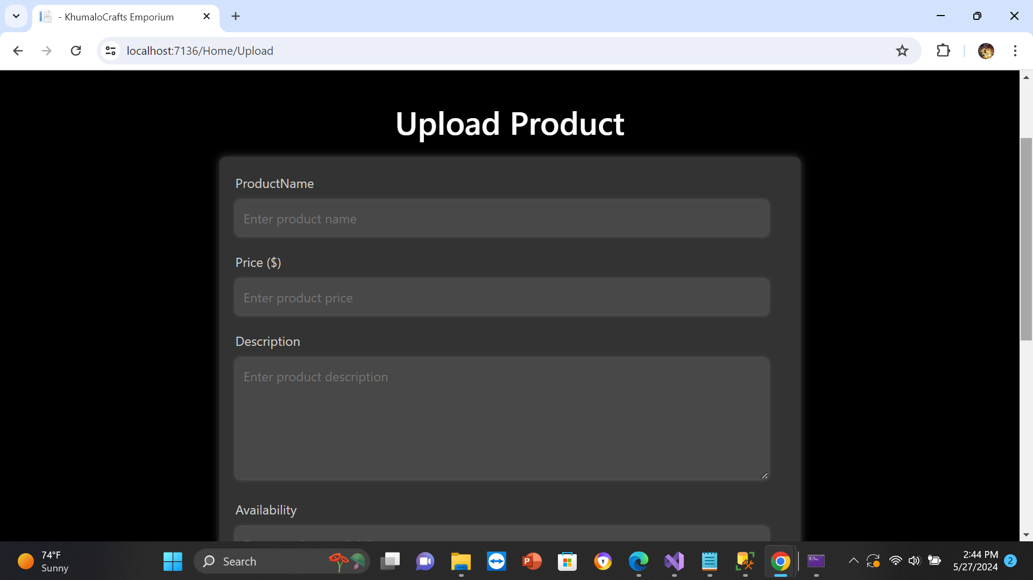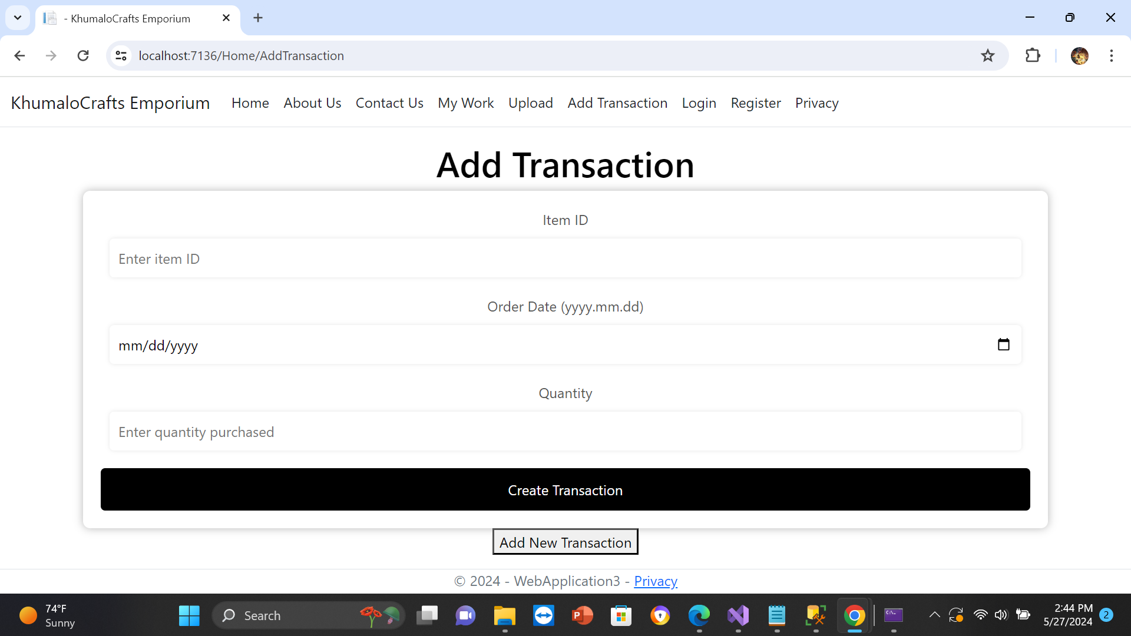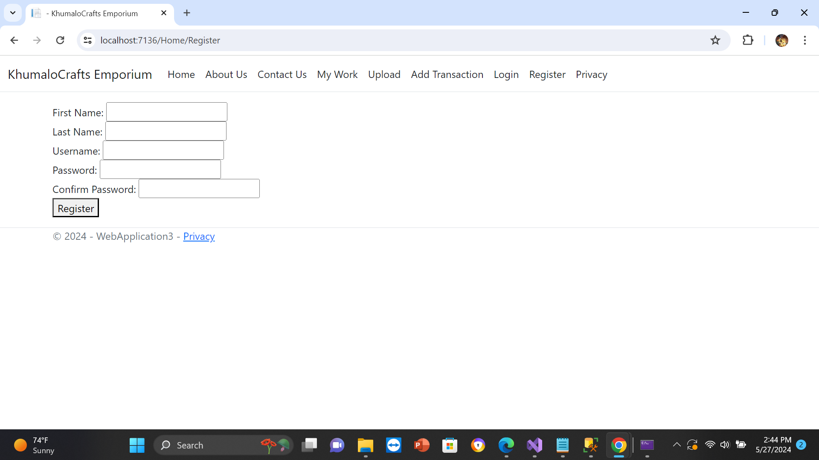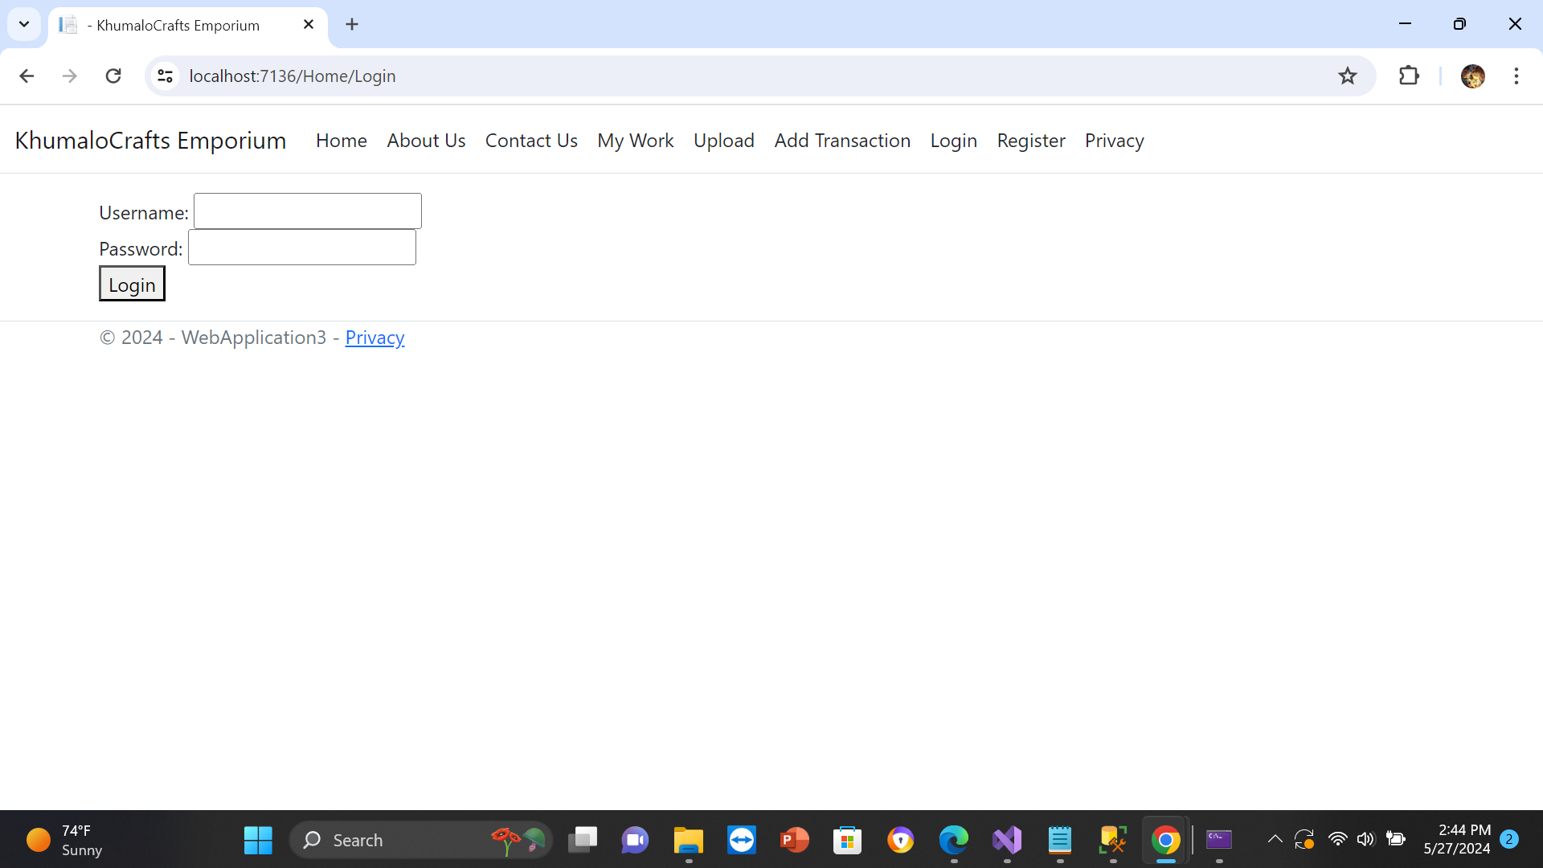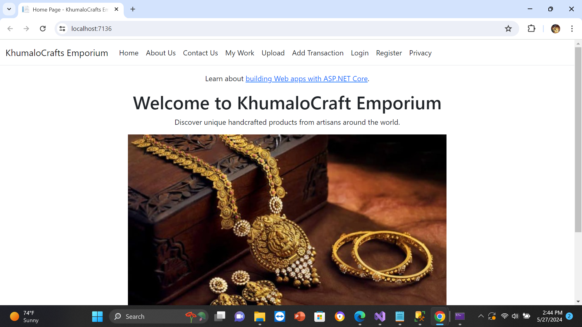

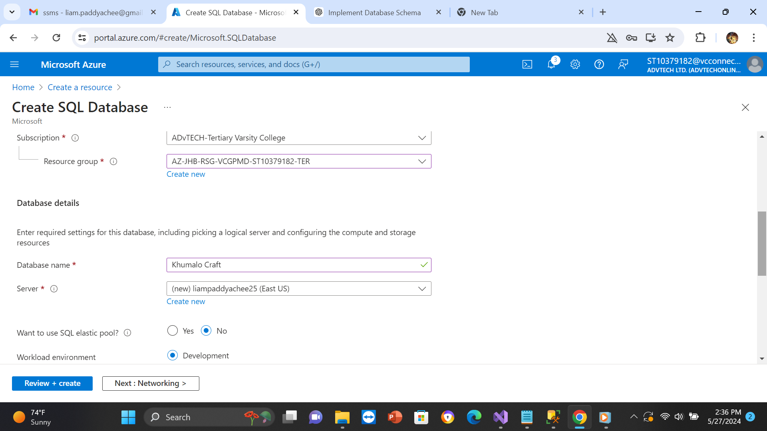

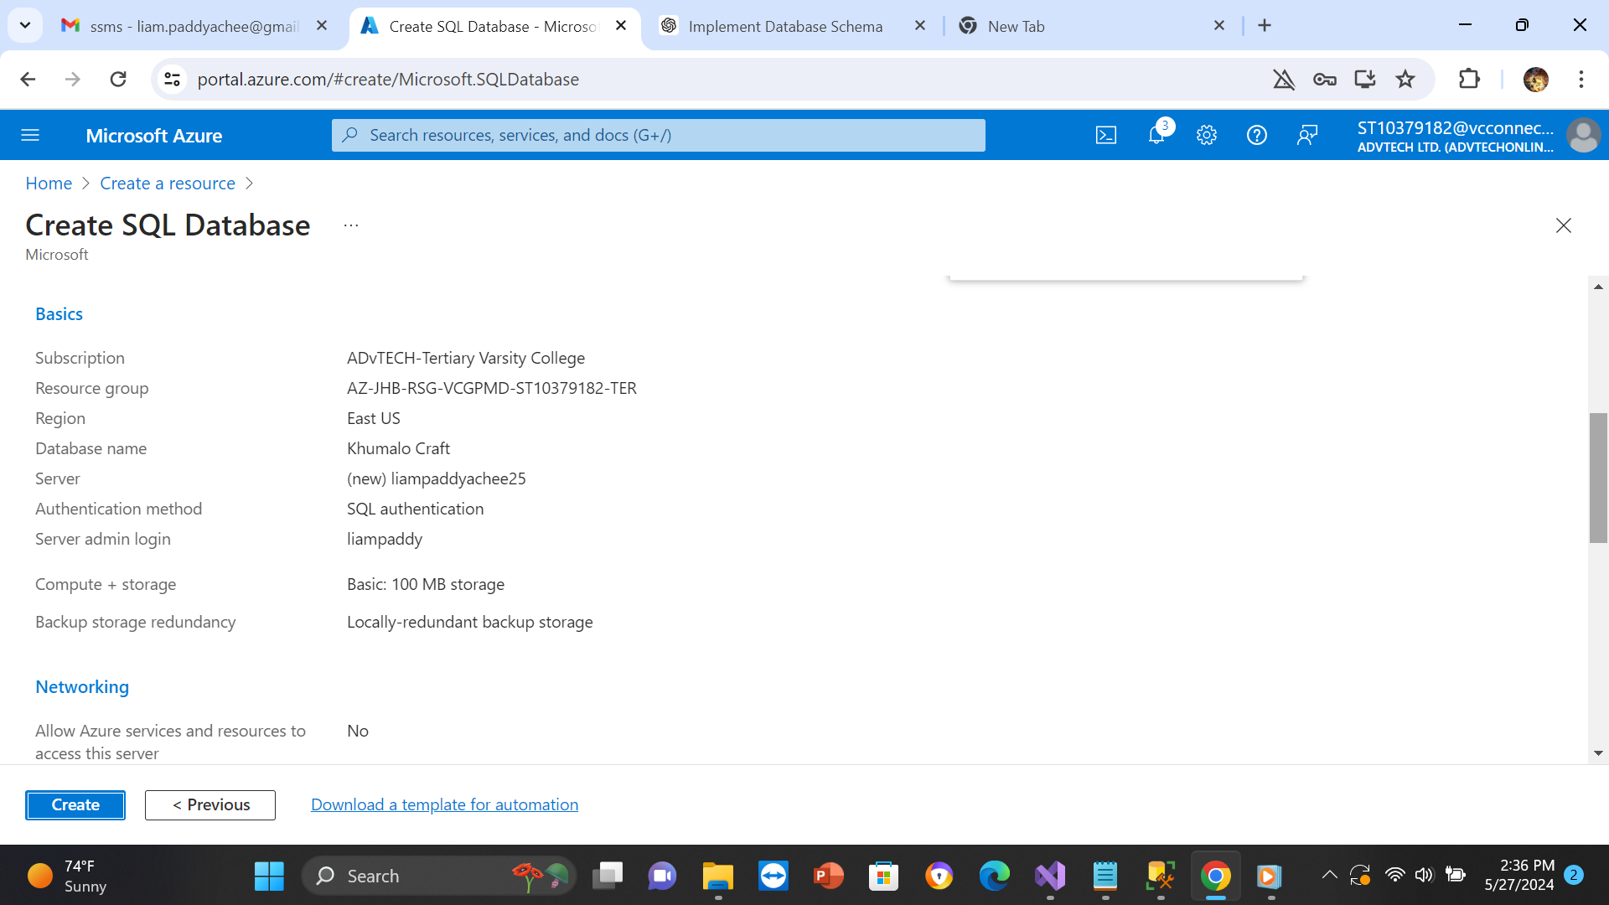

References:  
  
1. Groovetechnology.com, 2023

How to Develop ASP.NET Web Applications? [22 June 2023]

Available at: <https://groovetechnology.com/blog/how-to-develop-asp-net-web-applications/>

[Accessed on 19 May 2024]

2. Learn.microsoft.com, 2024

Continuous deployment to Azure App Service,

[29 February 2024]

Available at: https: <https://learn.microsoft.com/en-us/azure/app-service/deploy-continuous-deployment?tabs=github%2Cgithubactions>

[Accessed on 20 May 2024]

3. docs.telerik.com, 2017

Creating a New Web Application [2017]

Available at: <https://docs.telerik.com/data-access/quick-start-scenarios/asp.net-web-app/getting-started-root-quickstart-aspnet-getting-started>

[Accessed on 20 May 2024]

4. techtarget.com, 2024

Generative AI brings changes to cloud-native platforms, [9 November 2023]

Available at: <https://www.techtarget.com/searchitoperations/news/366558957/Generative-AI-brings-changes-to-cloud-native-platforms?utm_source=google&int=off&pre=off&utm_medium=cpc&utm_term=GAW&utm_content=sy_lp03182024GOOGOTHR_GsidsITOperations_Cyberark_Essential_IO272357_LI2777993&utm_campaign=Cyberark_ETO_sITOps_EMEA&Offer=sy_lp03182024GOOGOTHR_GsidsITOperations_Cyberark_Essential_IO272357_LI2777993&gad_source=1&gclid=Cj0KCQjw2a6wBhCVARIsABPeH1vLwTqGHuvaKePz-8hY3SAosL1TyMUnqqmOOIsrYqFiUNpceMhyI-QaAo6-EALw_wcB>

[Accessed on 23 May 2024]

5. Azure.microsoft.com, 2024

What is cloud computing?, 2024

Available at: <https://azure.microsoft.com/en-us/resources/cloud-computing-dictionary/what-is-cloud-computing#:~:text=Simply%20put%2C%20cloud%20computing%20is,resources%2C%20and%20economies%20of%20scale>

[Accessed on 23 May 2024]